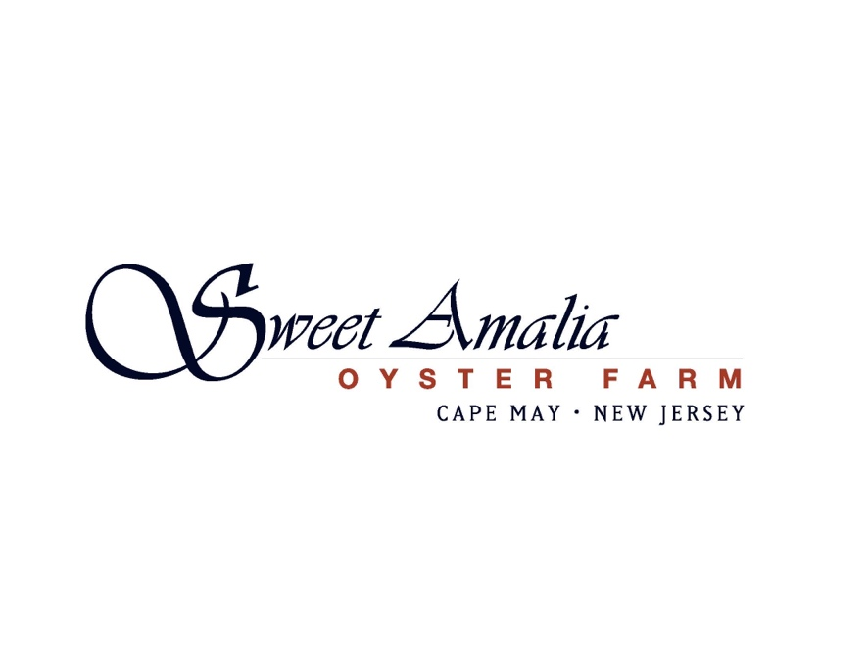

Farm Hand Job Opportunity – Sweet Amalia Oyster Farm
Spring-Summer 2025

Location: Cape May, New Jersey

Position Type: Part-time seasonal, May-August with possibility to extend. Work schedule is tide dependent, as such reporting time shifts by 1 hour from day to day.

About us: Sweet Amalia is a woman owned oyster farm located in southern New Jersey. We grow and direct deliver from tide-to-table high quality oysters to some of the finest restaurants in the Philadelphia area. We also co-own a sister farmstand and restaurant— Sweet Amalia Market & Kitchen, listed by Esquire as one of the Best New Restaurants in America 2022 and New Your Times as one of the top 50 restaurants in America 2024.

We are looking to expand our team to help us develop the farm to its full potential. This is an exciting time to be working in the field of shellfish aquaculture and we’d love to bring dedicated team members with interest in building a future with Sweet Amalia.

Role Summary: We are seeking motivated, reliable, and energetic crew members. The farm hand position is a field-based position at our farm located in the Cape May Court House, NJ area. As a team member you will assist with all farm-related tasks (including sorting, grading, and washing oysters). This is dirty and muddy work, but the surrounding environment is beautiful. Must love being outdoors and be able to lift 50 lbs.

Key Responsibilities:
- Conduct husbandry practices to control biofouling on gear, equipment, and oysters
- Operate farm equipment including an atv, tumbler and pumps
- Deploy and care for seed stocks
- Maintain appropriate stocking densities of oyster stocks
- Sort oysters for prime and secondary market standards, following established criteria
- Shuck oysters at events & run sales associated with mobile raw bar
- Assist with farm tours
Qualifications:
- Willing and able to follow instructions
- Strong, clear communication skills
- Ability to work independently and as part of a team
- Willingness to work outdoors in various weather conditions
- Physical capacity to work on your feet on the water, and lift/push/pull up to 50 lbs
Preferred Skills and Traits:
- Highly organized and adaptable to new challenges
- Keen attention to detail
- Troubleshooting skills and the ability to identify and address issues quickly
- Enthusiastic about outdoor work environments, sustainability, aquaculture, and small business
- Capable of working both independently and collaboratively
Compensation:
- $16-$17/hr; individuals with specialized skill sets may be considered at a higher pay rate
How to Apply:
Please send a cover letter, resume, and three references to: lisa@sweetamalia.com

