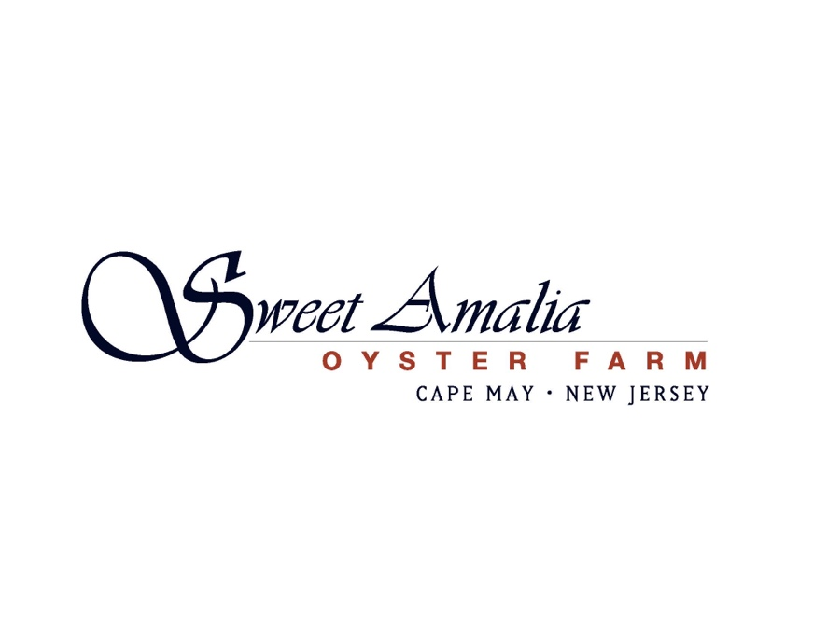

Farm Manager Job Opportunity – Sweet Amalia Oyster Farm (Spring-Fall 2025)

Location: Cape May, New Jersey
Position Type: Full-time, Spring Start Date - TBD Fall End Date

About us: Sweet Amalia is a woman owned oyster farm located in southern New Jersey. We grow and direct deliver from tide-to-table high quality oysters to some of the finest restaurants in the Philadelphia area. We also co-own a sister farmstand and restaurant— Sweet Amalia Market & Kitchen, listed by Esquire as one of the Best New Restaurants in America 2022 and New Your Times as one of the top 50 restaurants in America 2024.

We are looking to expand our team to help us develop the farm to its full potential. This is an exciting time to be working in the field of shellfish aquaculture and we’d love to bring dedicated team members with interest in building a future with Sweet Amalia.

Role Summary: We are seeking a motivated, reliable, and energetic Oyster Farm Manager to oversee day-to-day farming operations. This leadership role entails overseeing crew, scheduling, stock management, sorting, culling, and grading oysters, as well as managing biofouling and landing market-sized product. The manager will lead a farm crew of 1-4 individuals and is expected to exhibit excellent communication, safety awareness, strong prioritization skills, and a supportive leadership style. The position entails 5-day (periodically overlapping weekends), 40-hour workweeks from March through November/December, with potential for year-round employment based on performance.

Key Responsibilities:
- Lead a 1-4 person farm crew with safety and efficiency prioritized
- Plan daily schedules around farm accessibility/tides and seasonal needs
- Conduct husbandry practices to control biofouling on gear, equipment, and oysters
- Coordinate and communicate farm harvest, operations and needs with owner
- Maintain and operate farm equipment including an atv, tumbler and pumps
- Deploy and care for seed stocks
- Maintain appropriate stocking densities of oyster stocks
- Sort oysters for prime and secondary market standards, following established criteria
- Harvest oysters following state Vibrio regulations
- Conduct record-keeping for harvest regulations, quality control, inventory, and farm maintenance
- Utilize computer applications for reporting, logging, and maintenance records
- Repair, maintain, and deploy gear as needed
- Collaborate with the owner to improve farm efficiency
- Manage farm supplies
- Reposition farm (moving racks between deeper and shallower areas of farm in spring and fall)
- Shuck oysters at events
- Assist with farm tours
Qualifications:
- Minimum 2 years of farming, management, or related experience (oyster farming experience preferred)
- Valid driver's license
- Strong, clear communication skills
- Ability to work independently and as part of a team
- Willingness to work outdoors in various weather conditions from March to December
- Physical capacity to work on your feet on the water, and lift/push/pull up to 50 lbs
- Familiarity with operating and maintaining pumps and ATV
Preferred Skills and Traits:
- Highly organized and adaptable to new challenges
- Keen attention to detail
- Troubleshooting skills and the ability to address issues quickly
- Enthusiastic about outdoor work environments, sustainability, aquaculture, and small business
- Capable of working both independently and collaboratively
- Ability to shuck oysters cleanly and carefully
- Mechanical skills
Compensation and Perks:
- Competitive salary, dependent on experience starting at $25/hour
- Opportunity to grow with and develop a future with the business
How to Apply:
Please send a cover letter, resume, and three references to: lisa@sweetamalia.com

